CEN 4010 Principles of Software Engineering Spring 2021

Florida Atlantic University

Milestone 1 Project Proposal and High-level description

Group 12

**Project Name: Security Book**

Bryan Perdomo – bperdomo2016@fau.edu

Adam Batat – abatat2020@fau.edu

Mahri Almazova – malmazova2017@fau.edu

Colton Johnson – johnsoncolto2018@fau.edu

Ian Coston – icoston2016@fau.edu

02/16/2021

History Table:

|  |  |
| --- | --- |
| 04/04/21 | Revisions |
|  |  |
|  |  |
|  |  |

**2 Executive Summary**

The final project will be a social media website where users can connect to each other virtually anytime, to help aid with the constraints of having to quarantine due to Covid-19. The idea will start with a sign in screen that will allow users to sign in with SSO, or, they can register and create their own account. After signing in, users will be presented with their dashboard, which will show posts from other users they follow. There will be a search bar to find any registered member, as well as a button for them to follow/connect with those members. This site will also include many features you would find on any other social media network.

The main purpose for this site being created is because there are currently a lot of controversies with the mainstream platforms on the market. The biggest issues users face are privacy issues and company dishonesty. This application will be different from the others as it will protect the user’s information by not collecting and selling data. This site’s main goal is to maintain our reputation as honest by not selling user data, and to add a layer of encryption to protect users from malicious users trying to steal data. All of this combined will allow the user to navigate a social network that is not only user friendly, but also extremely secure with various layers of protection.

This website will be projected towards the common internet user and everyone in between. The reason why we are aiming for the common user is because many people are not very confident with technology. This website will alleviate the stress and worry for user data getting stolen, as well as it being a simple and easy to learn site.

**3 Competitive Analysis:**

|  |  |
| --- | --- |
| SecurityBook’s Features | Competitors Features |
| * Allows the creation of groups * Easy to search for friends and family * Will not have advertisements * Will never sell user data | * Allows the creation of groups * Easy to search for friends and family * Has advertisements * Involved in numerous controversies with selling data |

When developing and designing this website, our goal is to include as many features as we can that are found on most popular social media websites. These features include, but not limited to: a search bar to aid finding new friends, the ability to update your profile page, allowing users to share pictures and videos with friends, requiring users to create an account, and allowing users to like posts created by other users.

SecurityBook’s main difference to our competitors is to focus on keeping our users and their data safe. We want the users to believe that we will never collect and sell their data. Numerous mainstream companies have been caught stealing and selling their own users' data. We believe we would be making one of the safest social media websites for users to always stay connected, and more importantly, safe.

**4 Data definition**

Users – Users of the application, anyone who has direct interaction with the application

App – SecurityBook web system

String – User’s information, such as name and cities, will be stored in a string type.

Integer – User's information, such as date of birth, will be stored in an integer type.

GroupID - Unique group id number to differentiate each group.

UserID – Unique id for each user to differentiate between them.

Description – A description used to describe what a group is about

Search – Allows the users to search for other users and groups.

CreatePost – Allows the users to create a post for other users to see and comment on.

CreateComment – Allows the users to add a comment to other users posts.

SharePost – Allows users to share a post to others.

CreateGroup – Allows users to create a new group.

DeletePost – Allows users to delete a post they have created.

Like/Dislike – Allows users to like and dislike any posts.

SendMessage – Allows users to personally send a message to user/users.

**5 Overview, scenarios and use cases**

Like other social media websites, the SecurityBook app is built on the idea of sharing content, connecting with others, and getting involved with the community. It provides a platform that brings people together and lets them express their point of view. However, the main focus of SecurityBook app is to provide security and privacy to its users. Let’s say a user is looking for a way to stay connected to all his/her friends, family, and followers, but his/her main concern is to keep the companies from collecting confidential information such as location, interests, and preferences, and search history. SecurityBook would be a great choice as it provides this user the confidentiality that he/she is looking for, and it has all the main features that can be found in similar apps.

When the users first enter, they get two options to choose how they would like to continue to the app. If it’s a first-time user, he/she can choose an option to register to the website. Once the registration process is complete the user will get a welcome message and proceed to the dashboard.

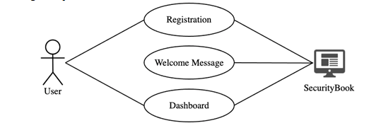

The users can also choose to log in to the app where they can use SSO login or SecurityBook login. Once the users are in, they receive a welcome message and continue to the dashboard.

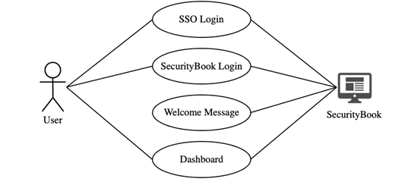

On the dashboard, the users see the posts of the people they follow, and from there they can like, comment, and share the content. There is a search bar that allows searching for other users by their name or a username, and posts by using a keyword. The users can follow anyone on the app as well as unfollow someone from their following list. On their main page, the users can share their pictures, videos as well as written posts. The app also allows its users to create groups or join an existing group where they can send messages as well as attach different files. Once the user is done using the app, he/she can exit at any moment by clicking on the Logout button.

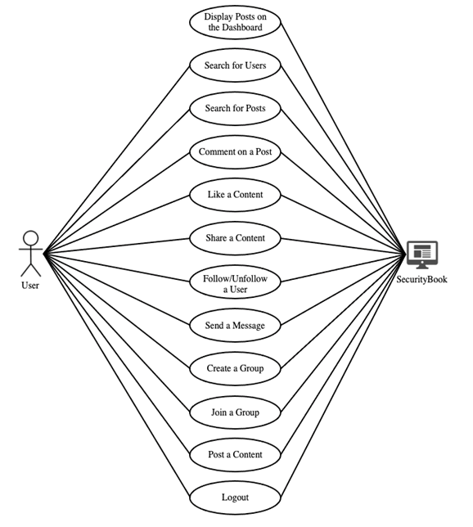

**6 High-level functional requirements**

1. Create a user dashboard containing posts of other users they follow with their account. This is like an activity page, where posts of followed users will appear on the dashboard in a chronological fashion from the most recent post to the most dated post. **1**
2. Users should be able to register and create unique accounts. Accounts will be unique to a user so that no two users have the same login information or registered email unless it is a guardian registering for a dependent. **1**
3. Users will be able to search for other users with a search bar directing them to other registered users. If two users have the same name then the one that is closest in location or has mutual friends/followers will appear at the top. **2**
4. Design a follow button that will connect users to one another and show their posts on each other’s dashboards. **2**
5. Allow users to create and join unique groups. Groups can not be the same exact group but may have the same name. **1**
6. Design a group ID to differentiate between two groups that may have the same name but for different reasons. **1**
7. Design a “Groups” page showing the groups the user has joined, recommend groups to join that mutual followers/friends have joined as well. **3**
8. Allow users to post videos, images, texts, and other forms of media. This will post to their own profile and their and their follower’s dashboards in chronological order. **1**
9. Add multi factor authentication to prevent hacks and maintain authenticity of users. (main feature) i.e. Much like the way Duo Mobile works with FAU. **2**
10. Design a friends/followers page or bar that allows users to go directly to pages of users they follow or groups they are in. **1**
11. Add a messaging system that allows users to communicate with other users or their entire group. **2**

**7 List of non-functional requirements**

1. The system will respond to user action within 1 second, and a user will wait no longer than one second for their action to register unless it is slowed down due to a fault.
2. The system will be easy to use for those without a background in technology. The common user who can access a website will be able to access the working site within 1 second of navigation to it and have the option to use SSO without issue until they decide to make an account.
3. The system will be available in all languages with an option to declare languages with the SSO account or the registered one. The system will also have instant-links that bring users to a specific group or personal page allowing them to connect without issue.
4. The system will be able to accommodate 10,000 users at a time without issue.
5. The system will not store any transactional data or website visits of the users as to maintain the main principle of SecurityBook. Login information will have to be stored and encrypted to protect the users secure information.
6. The system will be able to store login information of over 10,000 users without issue.
7. The system will be available whenever a user needs to use it unless the system is under a maintenance window at which point certain features or the whole system will be unusable until there is a fix, ideally a 3 hour window in which the fix(es) can be made.
8. The system will perform under minor faults at a slower speed, up to 2 times the original functional speed. Major faults may require maintenance.
9. The system will work identically on all OS types ( for example : Windows, Mac OS, and Linux) and on all common browsers ( for example : Google Chrome, Mozilla Firefox, and Safari)
10. Add an extra layer of encryption to protect user data from being stolen.

**8 High-level system architecture and database organization**

Database: phpMyAdmin

· UserID - with name to search

· GroupID - with keywords to search

· Account – Has all the functions to use the website, stores user information

· Group – Stores groupID, name, and a description

Media storage: Will be stored in pages and not in the database.

Search: Keywords stored into database for user retrieval. This is how the users will search for other users and for groups.

Each post will include a like and dislike button. The webpage will sort based on highest rating, so lower ranked posts are on the bottom.

Front-End:

· HTML/CSS/Javascript

Back-end:

· PHP

· SQL

· Javascript (Node.js)

Tools:

· phpMyAdmin

· Node.js

Libraries:

· jQuery

Frameworks:

· Bootstrap 5

· React, Angular

· Express

**9 High-Level UML diagrams**

OO class diagram that showcases what is stored in the database and what is included for each account and its functions. This diagram also shows what is needed for each group.

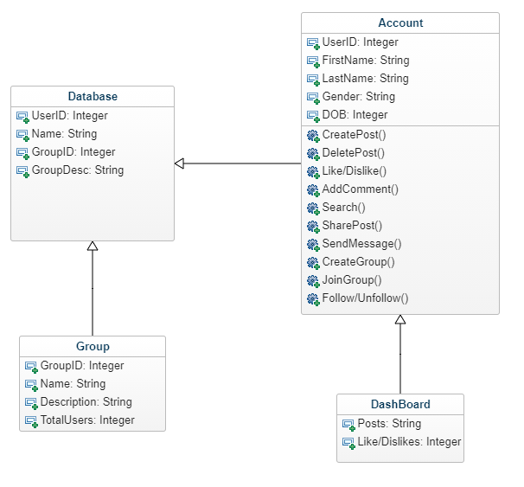

Deployment Diagram

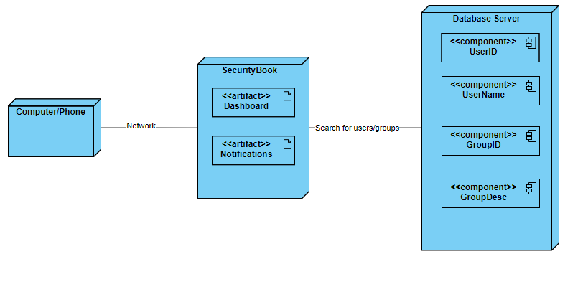

Component Diagram

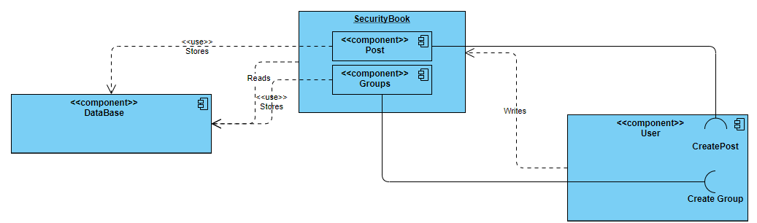

**10 Identify actual key risks for your project at this time**

* + - 1. Some skills risks we may run into are not being able to fully implement a layer of encryption to the website. We plan to solve this risk by doing as much research as we can before the deadline.
      2. With the given schedule, a good foundation of the project should be completed, so worst case scenario, we have an almost complete website. The solution to this risk is to properly manage our time to ensure we complete our goals.
      3. Technical risks include not properly implemented the database to the website. This is our first time implementing a database, so we may run into problems during development. Our solution to this risk is researching how to link a website to a database.
      4. Given our current deadline and with the ongoing Covid-19 pandemic, it is difficult for all of the group members to meet up online at the same time. Many parts of the software will be done individually, so meeting all of our specifications could be problematic. To solve this, we need adequate planning and properly dispersing the workload to each student.
      5. Legal risks include copyright with the name “SecurityBook” being very similar to “Facebook.” We will also not be purchasing any licenses for any tools used to build the webpage as this is strictly for learning purposes. To solve this risk, we would have to purchase any licenses needed, and create a more original name for the website.